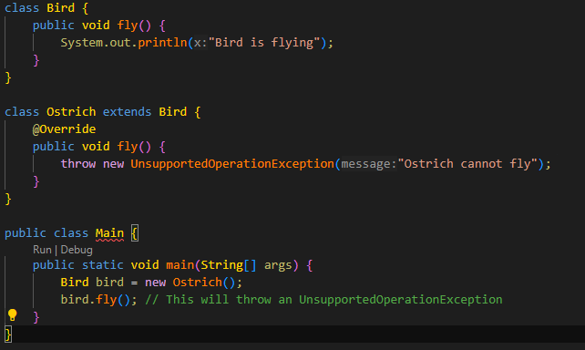
Liskov Substitution Principle:
This code violates LSP because Ostrich is a child of Bird and overrides the fly function since ostriches cannot fly. However, when we substitute the class with the parent class we will get an exception from the Ostrich. If we were to loop through all instances of Birds and their children the ostrich will throw the exception every time resulting in us not being able to substitute the parent class for the child class.
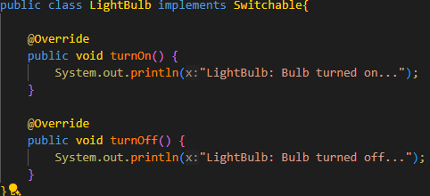
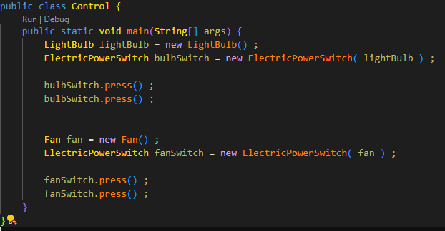
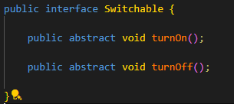
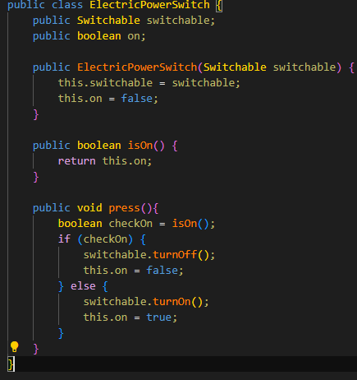
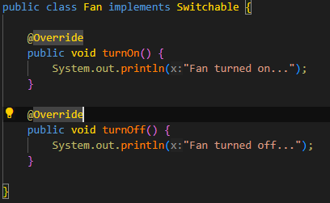

Dependency Inversion Principle:
I implemented a Switchable interface that has the two abstract methods turnOn and turnOff. I changed the lightbulb class to implement Switchable and added functionality for those two abstract functions. I also created a Fan class which also implements the same functions for its own functionality. I changed the ElectricPowerSwitch class to use Switchable instead of lightbulb or fan. This allows ElectricPowerSwitch to use anything that implements Switchable for more diverse functionality. Finally, I changed the control panel to add the new fan switch.

